**Priya Jain**

**180088**

***Objective: Bubble Sort***

1. **Bubble sort without recursion**

**CODE:**

#include<stdio.h>

#include<conio.h>

void bubble_sort(int A[],int n);

void main()

{ clrscr();

int i,A[100],n;

printf("\n enter the no. of elements");

scanf("%d",&n);

printf("\n enter the values for array");

for(i=0;i<n;i++)

{ scanf("%d",&A[i]);

}

bubble_sort(A,n);

for(i=0;i<n;i++)

{printf("%d\t",A[i]);

}

getch();

}

void bubble_sort(int A[],int n)

{ int j,k,temp;

for(j=0;j<n-1;j++)

{ for(k=0;k<n-j-1;k++)

{ if(A[k]>A[k+1])

{ temp=A[k];

A[k]=A[k+1];

A[k+1]=temp;

}

}

}

}

**OUTPUT:**

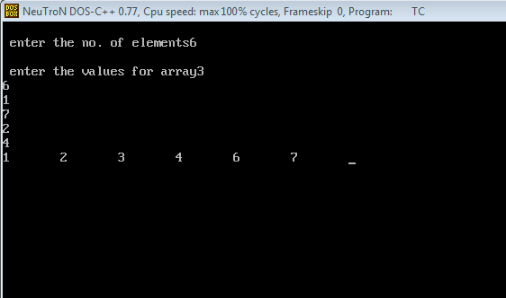

1. **Bubble sort with recursion**

**CODE:**

#include<stdio.h>

#include<conio.h>

void bubble_sort(int A[],int n);

void main()

{ clrscr();

int i,A[100],n;

printf("\n enter the no. of elements");

scanf("%d",&n);

printf("\n enter the values for array");

for(i=0;i<n;i++)

{ scanf("%d",&A[i]);

}

bubble_sort(A,n);

for(i=0;i<n;i++)

{printf("%d\t",A[i]);

}

getch();

}

void bubble_sort(int A[],int n)

{ int j,k,temp;

j=n;

if(j>0)

{ for(k=0;k<n-1;k++)

{ if(A[k]>A[k+1])

{ temp=A[k];

A[k]=A[k+1];

A[k+1]=temp;

}

}

bubble_sort(A,n-1);

}

else

{ return;

}

}

**OUTPUT:**

